**C/LTC Vanessa Smith-Manuel being presented with her end of commitment plaque. Her dedication and tireless efforts made possible all our Wildcats Battalion missions a possible under very stressful times. As she is becoming one of our own AJROTC Wildcats alumni’s she will continue to be a Wildcat Cadet for life.**

**“Live by the Creed”**

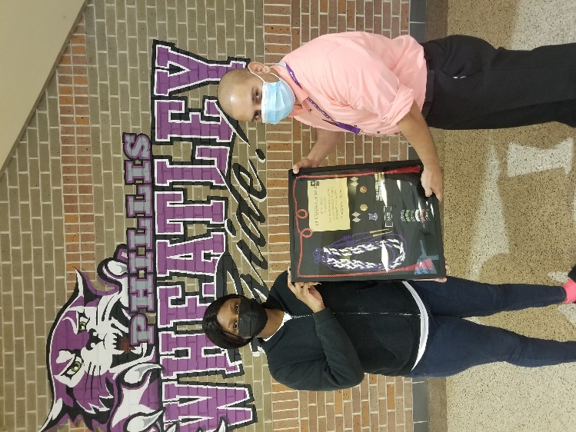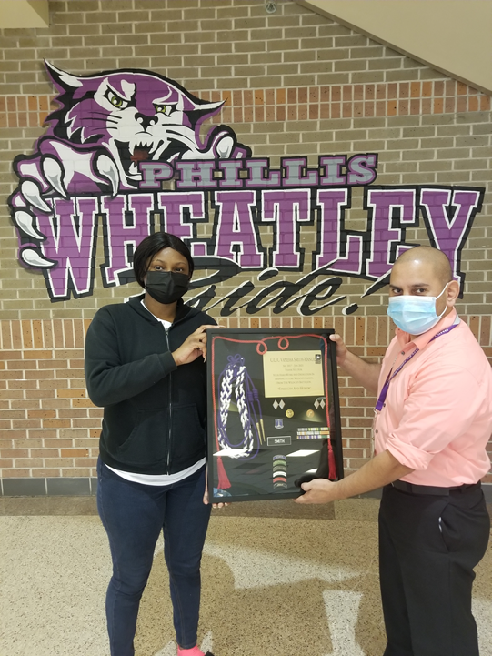

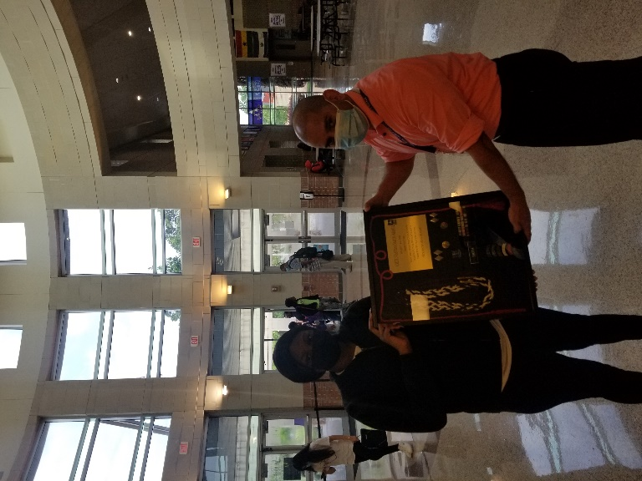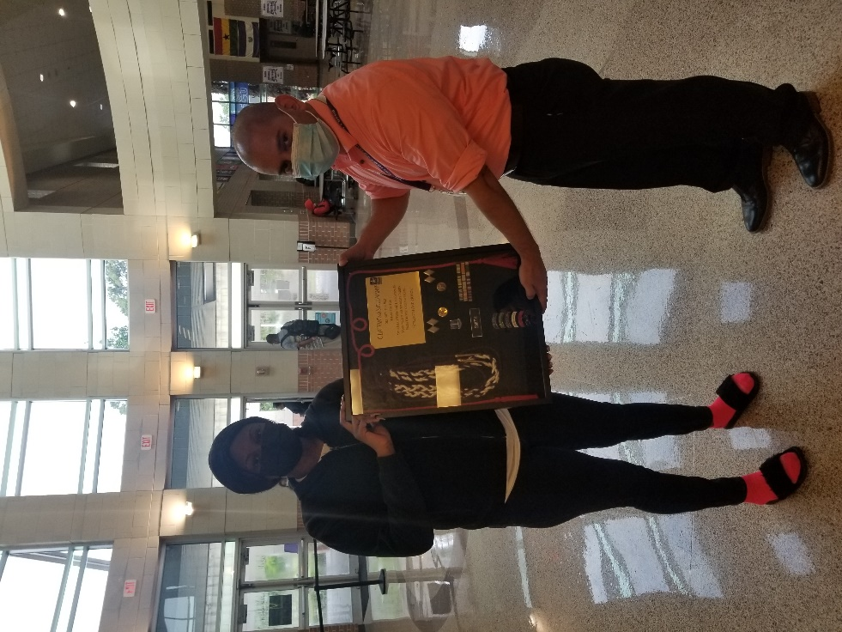

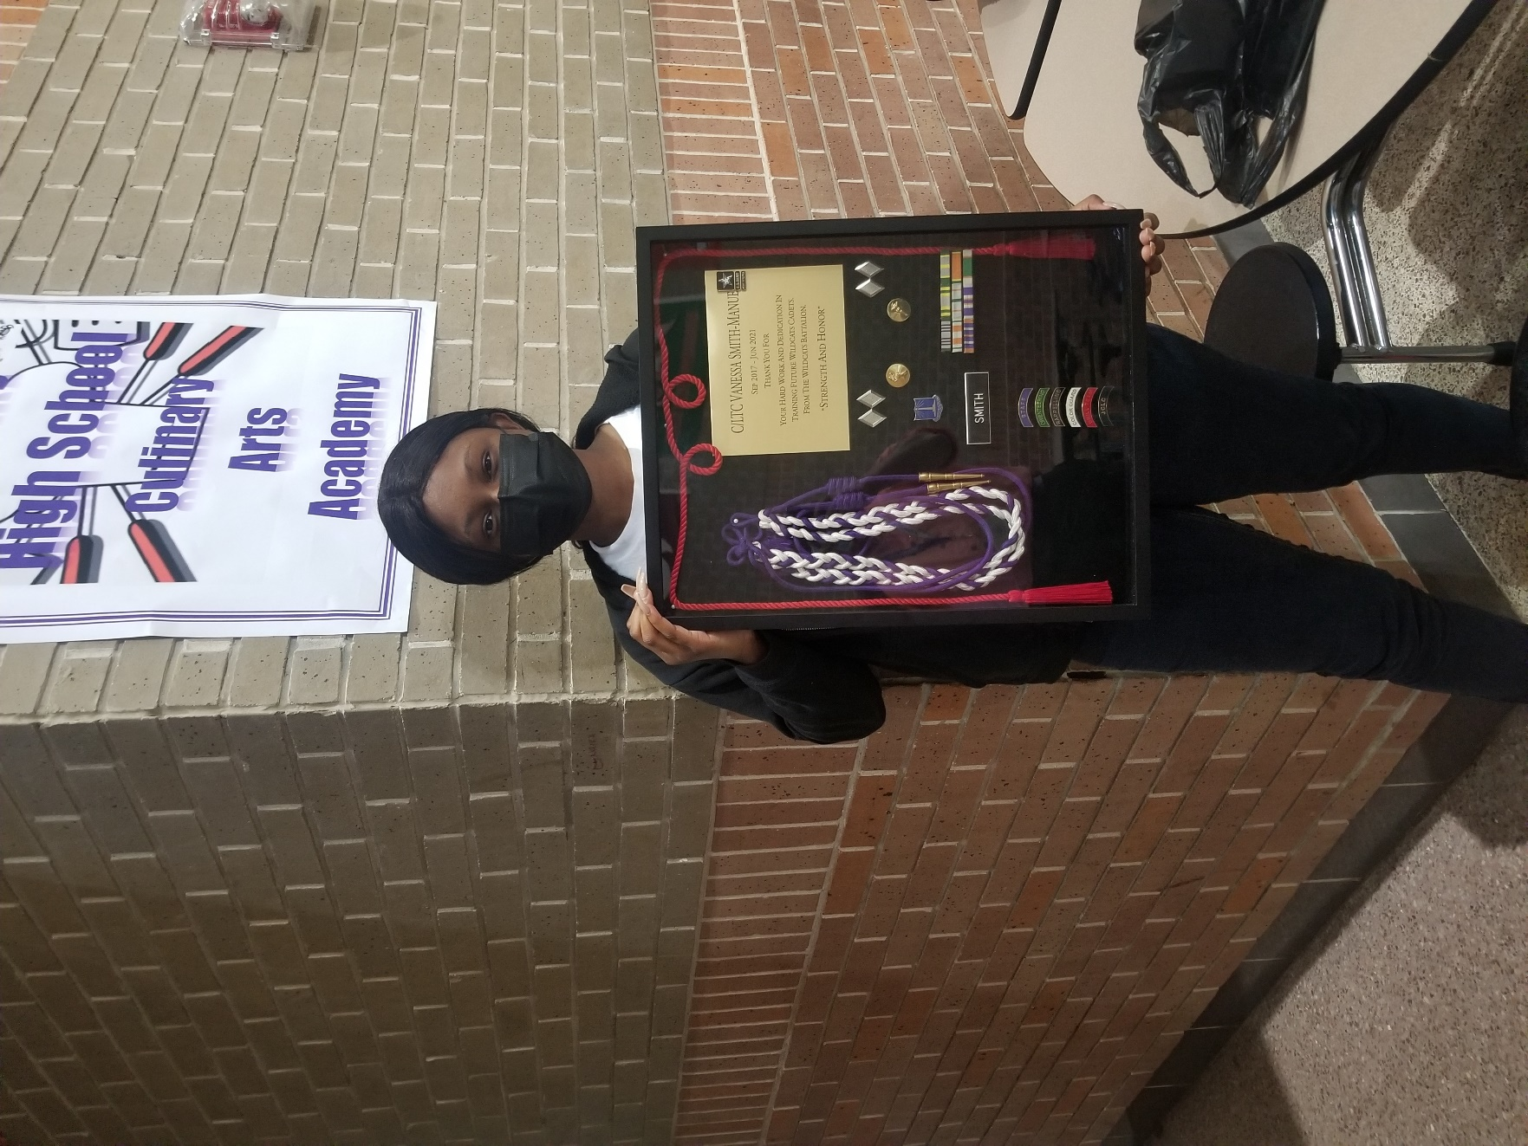

**Great Accomplishment by Our Senior Cadet. We all wish you the very best and Godspeed!!!**